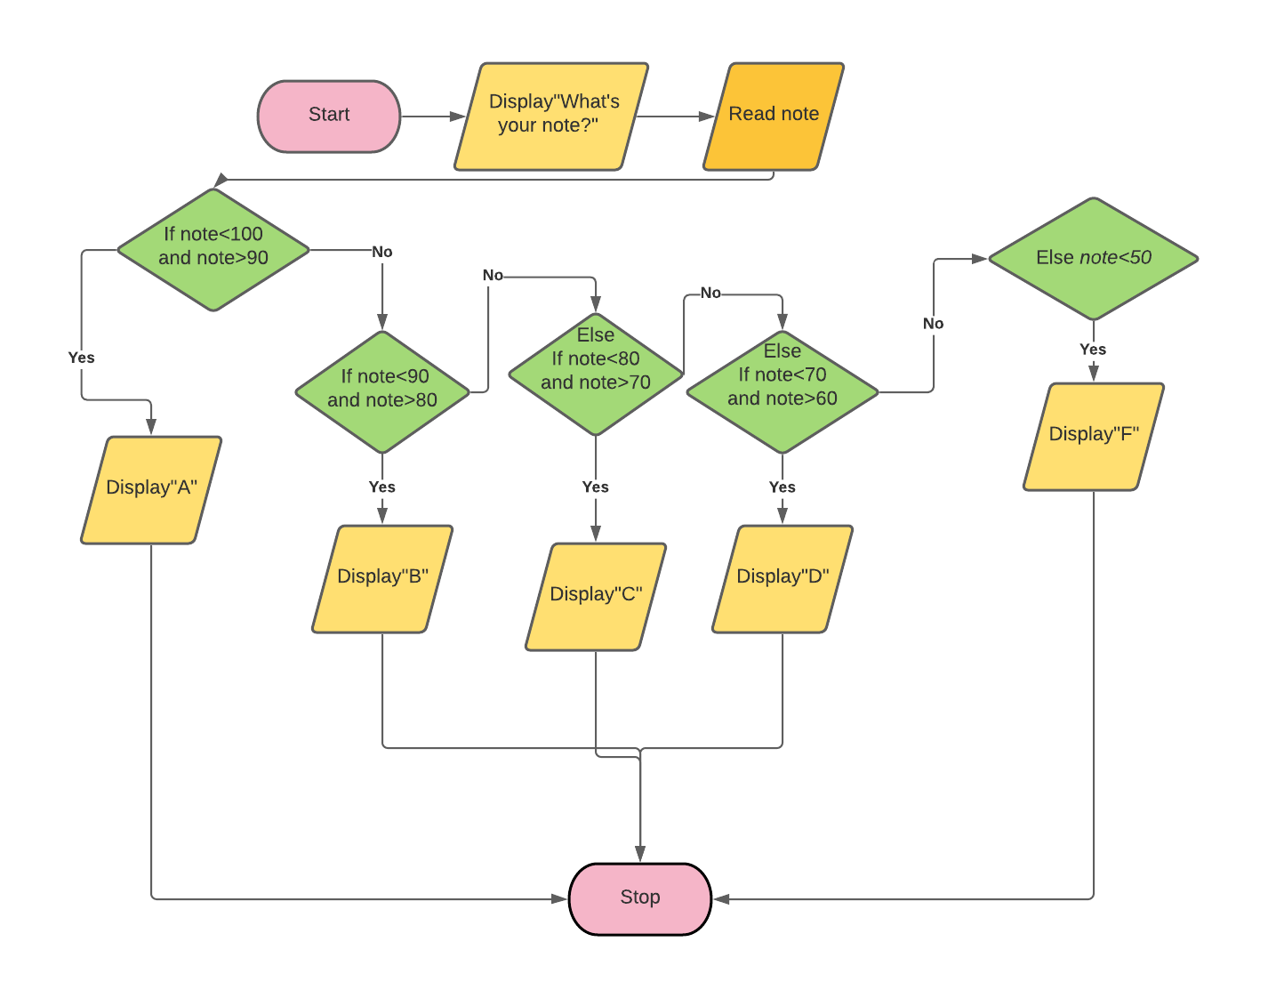

A1:Start

A2:Print”What’s your note?”

A3:Read note

A4:If note<100 and note>90

A5: Display”A”

A6:Else If note<90 and note>80

A7: Display”B”

A8:Else If note<80 and note>70

A9: Display”C”

A10:Else If note<70 and note>60

A11: Display”D”

A12:Else If note<60 and note>0

A13: Display”F”

A14: Stop